Project Report
Hospital Management System (HMS)
1. Project Title and Group Details
Project Title:
Hospital Management System (HMS) - A C++ GUI Application
Group Members:
- Asim Ahmad
- Wasi Ul Murtaza Alvi
- Hafiz Qazi Sharjeel Abdullah
- Rayyan Usman
Course/Class:
Computer Progamming
Instructor:
- Huzaifa Abbas
- Shah Muhammad
2. Introduction and Problem Statement
Introduction:
The Hospital Management System (HMS) is a desktop application we built from the ground up to make the work easy and simple for hospital administration.
Written in modern C++, it provides a secure, easy-to-use graphical interface where administrators, doctors, and patients can log in and manage their daily tasks.
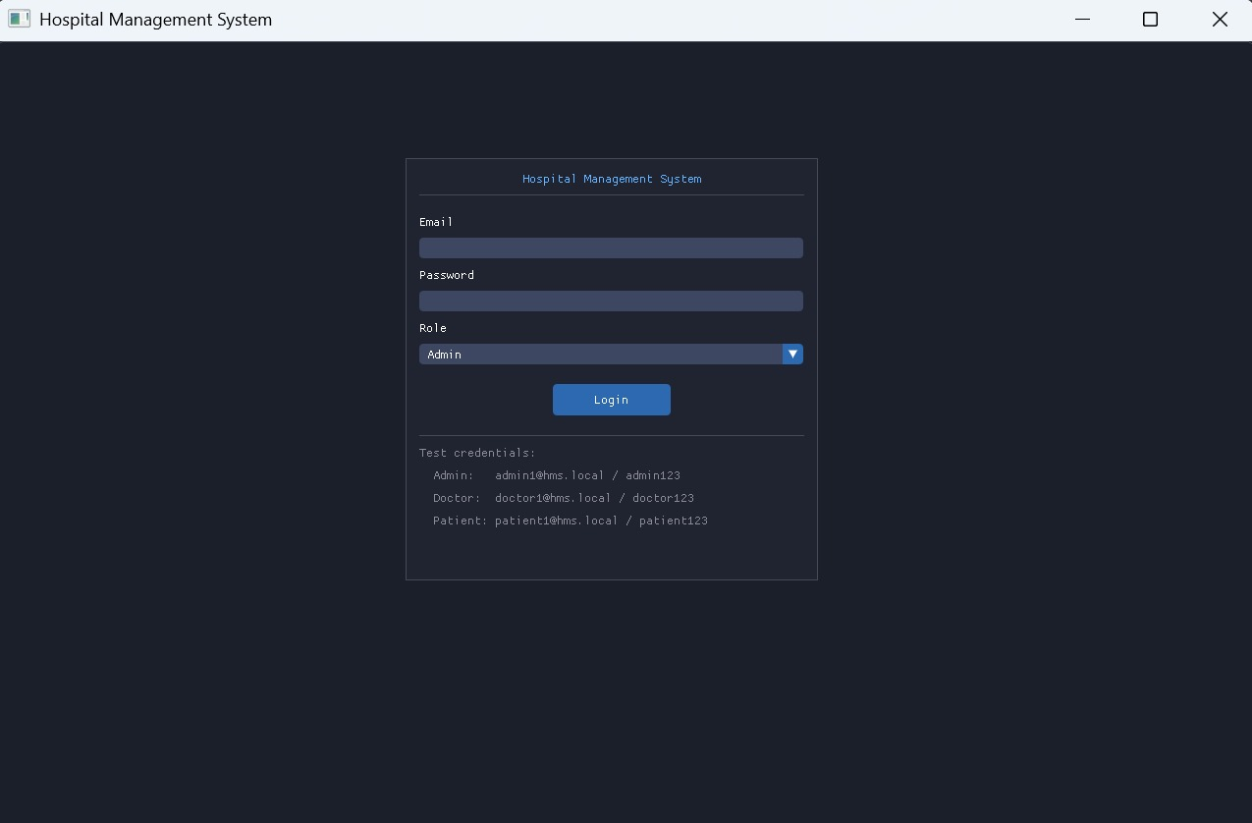
As there are three different categories to login whether as a;
- Admin
- Doctor
- Patient
Problem Statement:
Many local healthcare facilities still rely on paper records or outdated, clunky software. This creates a few major problems:
- Messy Records: Keeping patient history, billing, and doctor schedules in separate places leads to lost files and data entry errors.
- Slow Workflows: Manually booking appointments often results in scheduling conflicts and long wait times.
- Security Flaws: Without a proper login system, sensitive medical and financial data is left open to anyone who accesses the computer. We realized there was a need for a fast, centralized digital system that handles these operations securely, without the need for an expensive internet-based cloud server.
3. Project Objectives

When we started this project, we set out to achieve a few core goals:
- Secure Logins: Create a Role-Based Access Control (RBAC) system so Admins, Doctors, and Patients each get their own personalized, restricted dashboard.
- Doctors are added (with their information)

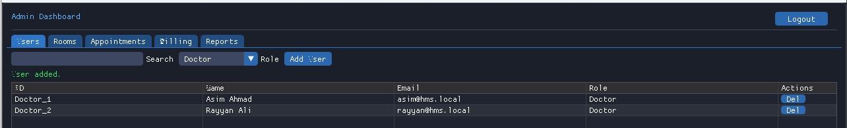
Doctor_01 info:
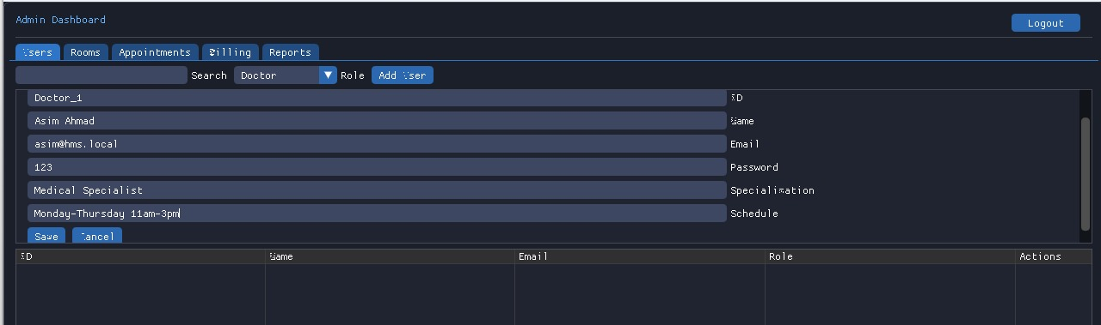

Doctor_02 info:
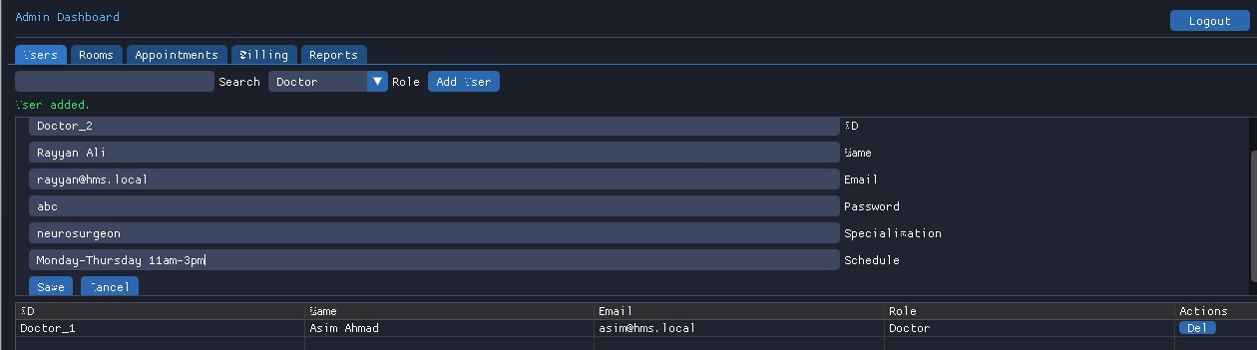
- Patients Added (with their information)
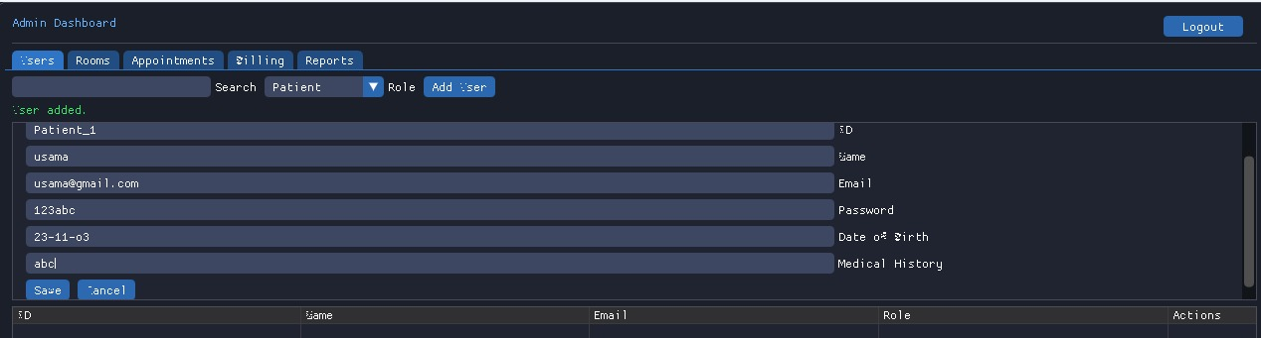
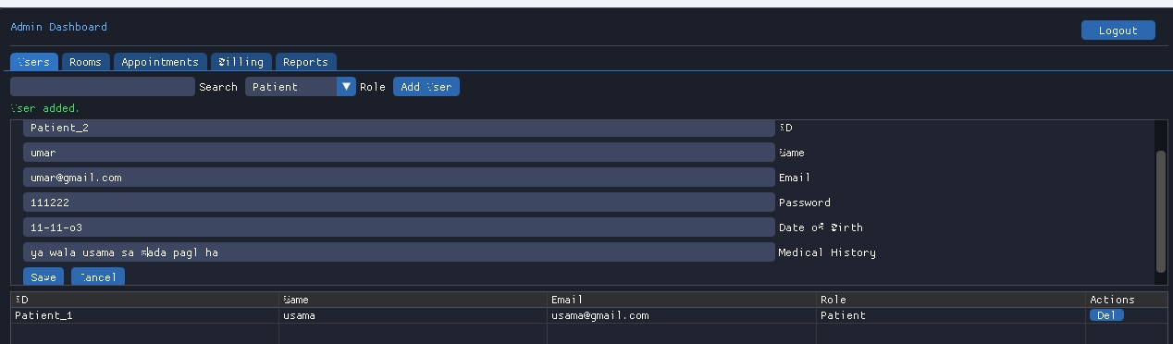

- Full Data Control: Give hospital administrators the ability and access to easily add, edit, view, and remove staff members, doctors, patients hospital rooms.
Patient Dashboard is accessed by admins,
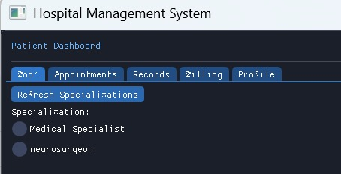
- Seamless Appointments & Billing: Build a workflow where patients can request a time slot, doctors can approve it on their end, and the system automatically generates a bill when the visit is done.
- Reliable Data Saving: Ensure that every single action is saved permanently to local CSV files, so no data is ever lost when the app is closed.
- A Modern Visual Experience: Move away from boring terminal windows (black screens with white text) and build a real, clickable graphical interface.
4. Proposed Solution or Methodology
To build a system this large without the code becoming a disorganized mess, we used strict Object-Oriented Programming (OOP) and a "Service-Layer" architecture. We divided the project into four distinct jobs:
- The Models (models/): These are our basic C++ classes. They act as digital blueprints for real-world hospital items.
- The Utilities : A folder for handy helper tools, like HashUtils for securing passwords and FileParser for reading our text files.
- The Managers : This is the brains of the operation. Classes like UserManager process everything the user clicks, enforce the rules, and tell the system when to save data.
- The UI : The visual layer that actually draws the buttons, tables, and tabs on the screen.
5. System Design and Architecture
Here is exactly what happens when you run our application:
- Starting Up: When you launch hms.exe, the system boots up the graphics window. Before you even see the login screen, our Manager classes quietly read all the local CSV files to load up the hospital's history.
- Logging In: When a user types their password, the system encrypts it and checks if it matches our records. It then figures out if they are a Doctor, Patient, or Admin and sends them to the right screen.
- Making Changes (Auto-Save): If a patient books an appointment, the UI tells the AppointmentManager. The Manager updates the schedule and immediately rewrites the CSV file on the hard drive. We don't wait for a "Save" button; it happens instantly.
- Our QA Tester: We also built a unique --phase11-check testing tool into the code. This lets us run an automated health check on all our logic before the visual interface even loads, ensuring our core code is bug-free.
6. Tools, Technologies, and Implementation
We chose our tech stack very carefully to balance speed with a good user experience:
- C++17: The core engine. We used modern C++ features (like smart pointers and standard vectors) because it runs incredibly fast and handles memory safely.
- CMake: Our building tool. It automatically glues all our different C++ files and third-party libraries together to create the final .exe file.
- SFML 2.6: This library talks to the computer's hardware. It creates the actual window on your desktop and registers when you click your mouse or type on the keyboard.
- Dear ImGui: We used this to design the interface. It allowed us to easily create the modern tabs, tables, and dropdown menus you see on the dashboards.
- Custom CSV Parser: Instead of forcing users to install a heavy SQL database just to run our app, we wrote custom code to neatly save and load data from simple .csv text files.
7. Results and Demo Highlights
Please insert your screenshots here before submitting.
- The Login Screen:


- Admin Dashboard:
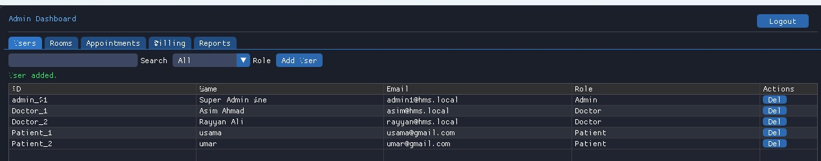
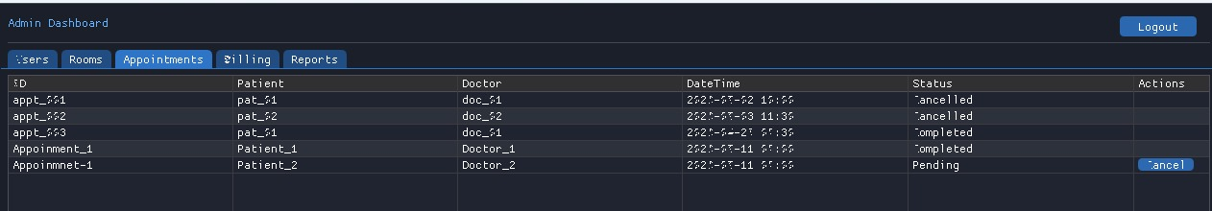
- Patient Dashboard:

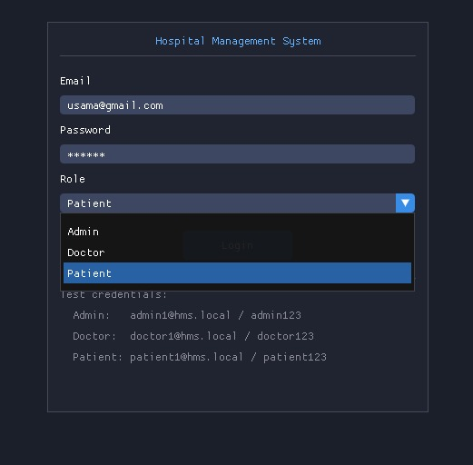

- Doctor Dashboard:
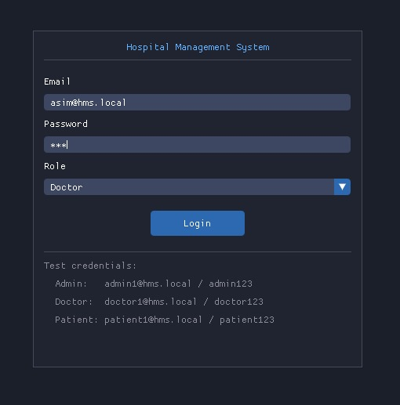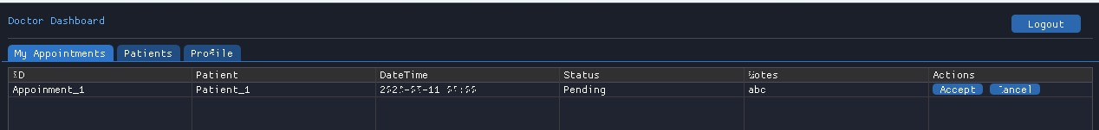
- Bill Criteria:
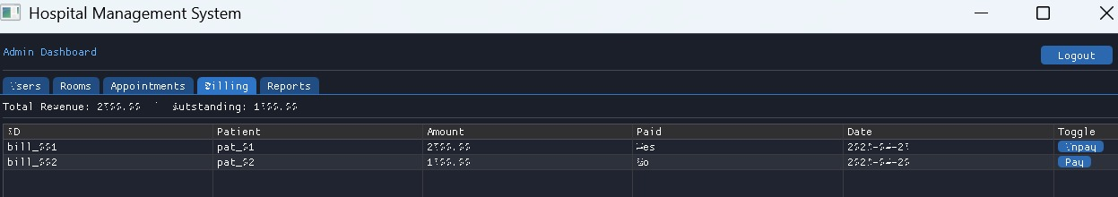

8. Challenges Faced and Solutions Applied
Building a large C++ app with an interactive graphical interface was not easy. Here are the biggest hurdles we overcame:
- Challenge 1: Getting the Graphics Libraries to Link
  - The Problem: C++ is notorious for making it hard to link external libraries. We spent a lot of time fighting with compiler errors just trying to get SFML and ImGui to connect properly on Windows.
  - The Fix: We completely rewrote our CMakeLists.txt file, using strict path flags to tell the compiler exactly where to find the graphics binaries.
- Challenge 2: The "Weird Symbol" Font Bug
  - The Problem: Once the UI finally loaded, our text was corrupted. Numbers like 0, 4, 5, and 6 were completely invisible, and capital letters looked like random symbols (like '^' and '*').
  - The Fix: We realized the ImGui font texture atlas wasn't scaling right. We dug into the initialization code and added a clean sequence to manually update the font texture before the first frame rendered, which brought all our text back perfectly.
- Challenge 3: Commas Breaking Our Database
  - The Problem: Because we were saving data in Comma-Separated Values (CSV) files, if a doctor typed a comma in a medical diagnosis, it would split the data into the wrong columns and break the whole file.
  - The Fix: We wrote a robust FileParser utility that sanitizes user input. We standardized exactly how multi-word strings and schedules are formatted before they are allowed to be saved.
- Challenge 4: Keeping Passwords Safe
  - The Problem: Originally, we were saving user passwords as plain text in the users.csv file, which is a massive security risk.
  - The Fix: We implemented a hashing utility using the djb2 algorithm. Now, when an Admin creates a user, the password is scrambled into a mathematical hash. Even if someone opens the CSV file, they cannot see the actual passwords.
- Challenge 5: Managing the UI State without Crashing
  - The Problem: ImGui redraws the screen 60 times a second. Trying to switch screens (like going from Login to the Dashboard) would sometimes cause the app to get stuck in a loop and crash.
  - The Fix: We built a strict state-machine system using boolean flags. The code now physically prevents the dashboard from rendering until the UserManager fully verifies that a user is successfully logged in.
9. Conclusion and Future Improvements
Conclusion:
We are incredibly proud of how this project turned out. By combining solid Object-Oriented C++ logic with a modern ImGui frontend and our own custom file-saving system, we built an application that feels like real, professional software. It solves the exact problems of messy paper records and slow hospital management we set out to fix.
What We Would Add Next:
- A Real Database: Upgrading from our CSV text files to a real SQLite database so the app can handle thousands of patients without slowing down.
- Network Support: Adding networking code so nurses, doctors, and receptionists can all run the app on different computers and see updates in real-time.
- Automated Alerts: Writing a feature that automatically sends an email or text message to a patient the moment a doctor approves their appointment.

